Working title: Effects of input subsidies on intensive versus extensive margin supply growth in the Tanzania’s dairy sector: implications for greenhouse gas emissions savings from land use change

James Hawkins, November 2017

Lancaster Environment Centre, Faculty of Science and Technology, Lancaster University

1. **Introduction**

Production of milk for consumption and sale is an important contributor to the livelihoods of the rural population in East Africa (Thornton et al., 2009; Tubiello et al., 2007). Dairy cattle provide a higher rate of return relative to other livestock for smallholder crop-livestock households (Udo et al., 2015). Market analyses (e.g. Omamo et al, 2006) suggest that increasing production in the dairy sector provides a higher contribution to both agricultural and total GDP growth relative to other sectors, for countries in East Africa. The Tanzanian government intends to grow its livestock industry (Ministry of Livestock Development, 2006), and its livestock development policy has the purpose of increasing food security, stakeholder’s incomes, and contribution to the national economy (LSDP, 2011, vi). The government aims to improve productivity and efficiency, from primary production at farm level, through to transportation, processing, and distribution (LSDP, 2011), and efforts for achieving these goals include increasing the supply of improved (crossbred) cattle, promoting the creation of? animal feeds market, increasing access to finance and credit and improving the regulatory efficiency of the value chain (MALF, 2016). The dairy sector also contributes approximately 25% of total agricultural greenhouse gas (GHG) emissions in the country (FAO, 2017), and is a further source of indirect emissions through driving the conversion of forests and grasslands to crop and pastureland (Carter et al., 2015; Pfeiffer et al., 2012). Meeting food security and climate objectives therefore requires that Tanzania implement policies in the livestock sector that allow for growth in milk production concurrent with declining GHG emissions.

Diet composition and quality are key determinants of efficiency in ruminant production systems (Blaxter 1965, AFRC, 1993). This, as well as animal characteristics, largely determine the feed use efficiency, which is a key determinant of GHG emissions intensities (Herrero et al., 2013). In Tanzania, animal genetic resources are primarily based on indigenous cattle (Mruttu et al., 2016) and the animal feed market and extent of production of high quality feedstuffs is low relative to neighbouring East African countries (MALF, 2016). Improving the quality of diets and adopting crossbred cattle have therefore been promoted as greenhouse gas mitigation strategies in the dairy sector (FAO, 2013). Policy interventions to improve access to inputs, access to milk markets, and to increase the participation in value chains have the general tendency to lead to the commercialization of milk production by households. This leads to what has been referred to as a ‘demand rebound’ by Valin et al. (2013), and impact assessments at household level generally find that these interventions increase both consumption and sale of milk (Shikuku et al., 2017, Paul et al., 2017), and therefore higher (absolute) GHG emissions. This therefore raises a fundamental problem of reducing (absolute) emissions concurrent with growth in milk production. In the modelling analysis of Mottet et al. (2015), improved herd performance and reductions in the total cattle population were found to lead to both lower absolute emissions and higher milk production in East Africa?. Increasing the relative share of productive to non-productive cohorts in the herd reduces the amount of feed required for, and the amount of emissions from enteric fermentation and manure attributable to non-producing animals (i.e. the ‘maintenance cost’). This, as well as higher milk yields from adult females, are found to lead to higher total milk production with a smaller herd size, and lower absolute GHG emissions. The population of both improved and indigenous cattle in Tanzania grows at greater than 2.5% per year (NBS, 2015), and given the important and multi-faceted role of dairy cattle in rural livelihoods (e.g. Weiler et al., 2014), there exist significant implications for rural livelihoods from promoting the transition to a smaller herd of higher performing cattle.

This study seeks to provide insight about the extent to which policies in the dairy sector can promote growth in milk production concurrent with reductions in absolute GHG emissions from smallholder dairy households. A mathematical programming model is used to simulate the effects of increasing access to improved animal genetics, animal feed markets, finance and credit, and access to milk markets on farm level production. The model choice variables are decisions with respect to milk production, including input use, stocking rate, adoption decisions of improved breeds, herd size, and herd composition, as influenced by the above policy interventions. Given that subsistence agriculture is a major local driver of forest conversion (Makunga and Misana, 2017), the effect of these policy interventions on (reducing) area expansion of crop and pastureland is assessed, to provide evidence by which direct emissions from the dairy sector could be reduced while also contributing to Tanzania’s goal of net reforestation/afforestation. The research objectives are defined as follows.

To determine whether policies with respect to input prices, output prices, and credit can lead to declining absolute GHG emissions concurrent with growth in milk production

To assess the welfare implications of these policies, and

1. To quantify the potential for reducing area expansion of crop and pastureland from the dairy sector

The study therefore provides a basis by which public and private actors can implement policies in the dairy sector so as to meet Tanzania’s climate initiatives concurrent with its livestock sector objectives.

1. **Methods**

**2.0 Overview**

Mathematical programming (MP) is a powerful tool for conducting positive analysis[1] of farm level decision making under hypothetical policy interventions or changing market conditions (i.e. prices of inputs or outputs). Such models combine decision making theory with biophysical simulation models representing dynamic feedbacks within and between different farm components (i.e. crops, grazing land, and livestock). Such models can therefore assess the effect of existing or proposed policy interventions on technology adoption decisions of households (and their constrains), on environmental indicators (including greenhouse gas emissions), and household welfare (Van Wijk et al., 2014). The MP modelling framework developed for this study aims to consider the decisions relating to management of the dairy enterprise, especially with respect to total milk production, quantity of cattle owned and structure of the herd, and land use, and to assess the implications of these outcomes for both absolute and intensity of emissions from milk producing households in Tanzania. The influence of changes in relative returns between dairy production and other farm activities (i.e. cash crops), and between allocation of land, capital, and labour to food production versus income producing activities is considered. Such an approach therefore allows assessing to what extent changes in input prices incentivize the household to increase milk production, and the extent to which this growth results from increasing productivity, as opposed to increasing herd size and land occupation. The feedbacks between dairy cattle numbers and land occupation is needed in order to assess the potential emissions savings from reductions in forest disturbance driven by feed requirements for dairy cattle.

Figure 2 illustrates the farm systems framework of the household, including livestock, household cash availability, and nutrient supply and biomass production. A livestock module is coupled to a cropping and grazing module, to assess the feedbacks between land allocation to food, cash, and fodder crops, and biomass availability for cattle, and the requirements for grazing land. The model simulates the household’s purchasing decisions with respect to feeds, local and improved cattle, as well as the allocation of available land to food, fodder, and cash crops, for both a baseline scenario representing current prices of inputs, and policy intervention scenarios representing various types of input subsidies (Figure 1). The livestock module simulates the changes in herd size, structure, and offtake, based on the effects of the feeding regimes on physiological characteristics of the herd, including growth rate and lactation milk yields. The cropping and grazing module specifies the supply of food crops for home consumption, fodder crops for feed, and cash crops for sale based on the assumed yields and model determined acreage under each scenario. The simulations are run for households representing different wealth classes and resource endowments, in order to identify how the household’s characteristics influence the household’s capacity for supply growth under given input subsidies (e.g. Hammond et al., 2017).

Figure 1: Analytical framework for farm-household level ex ante analysis

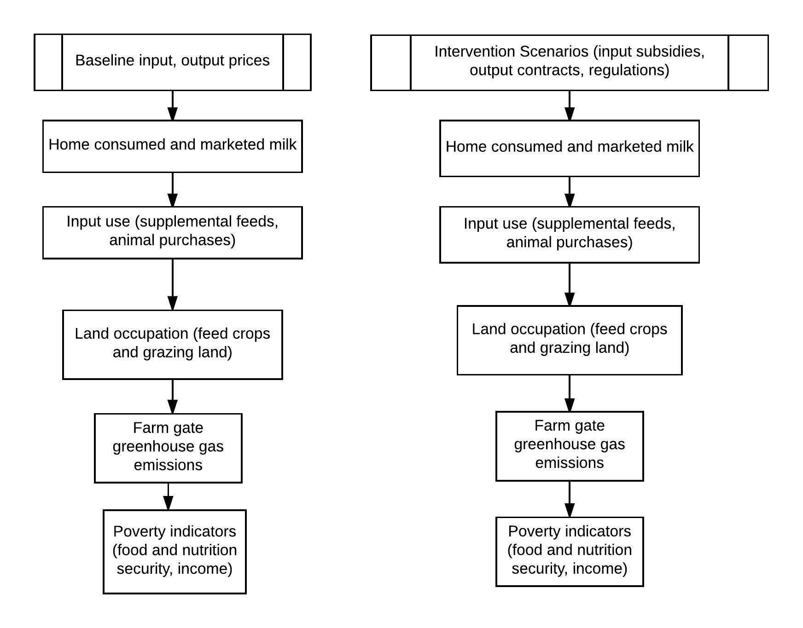

The household model is developed in the General Algebraic Modelling System (GAMS); a software package useful for developing optimization and simulation models for (Brooke et al, 2008). The model parameters are from household survey data gathered in the Tanzanian southern highlands milkshed region during the years 2017-2018 [list the names and affiliations of the surveys]. The administrative regions covered by the survey include Mbeya, Iringa, Morogoro, and Dodoma (Table 1). [Discuss basic agro-ecological and geographic conditions of region, including major markets for inputs and outputs, population, incomes].

Table 1: Site statistics

|  |  |  |  |  |  |
| --- | --- | --- | --- | --- | --- |
| Region | Agro-ecologies | Number of households | Population density | Average altitude | Average precipitation |
| Mbeya |  |  |  |  |  |
| Iringa |  |  |  |  |  |
| Morogoro |  |  |  |  |  |
| Dodoma |  |  |  |  |  |

Sources: NBS (2015)

Table 2: Income, resource endowments, household dependents, degree of market orientation, and input use by household

|  |  |  |  |  |
| --- | --- | --- | --- | --- |
| Parameter | Household types | | | |
|  |  |  |  |
| Food Crop only – Local Cows | Cash and food crop – local cows | Food crop only – improved cows | Food and cash crop – improved cows |
| Land holdings (ha) |  |  |  |  |
| Cattle holdings (hd) |  |  |  |  |
| Household members  (people) |  |  |  |  |
| Annual marketed milk surplus  (kg yr-1) |  |  |  |  |
| Off farm income  (Tsh yr-1) |  |  |  |  |
| Input Use | | | | |
| Breeding  Method | Natural breeding | Natural  breeding | Artificial Insemination | Artificial Insemination |
| Expenses on breeding and health services  (TSh TLU-1 yr-1) |  |  |  |  |

Sources: Surveys

Notes: All values are means of sample stratification.

The cost effectiveness of the input support policies considered with respect to the dual policy objectives of rural poverty alleviation and GHG abatement, respectively, are calculated as follows:

1. The cost-benefit ratio (CBR) of a given input subsidy is defined as the public cost of the policy with respect to the change in value of milk production caused after the policy is implemented. The public cost of the policy is defined as the change in mean input price for a given input in a given region multiplied by the change in aggregate consumption of inputs for a given household in region r. This is meant to assess the effectiveness of the policy with respect to rural poverty alleviation:
$${CBR}_{i,r}= \frac{∆{ (Mean Input Price_{i,r} ×Quantity of Inputs }_{i,r})}{∆ {(Value of Production}_{r})}$$

2. The cost effectiveness of the policy with respect to greenhouse gas mitigation is defined as the change in GHG emissions after the input subsidy is implemented relative to the public cost of the input subsidy:

CEi,r

Where CEi,r is the cost effectiveness of the input support policy with respect to greenhouse gas mitigation (Mg CO2eq TSh-1), and is the change in absolute emissions attributable to dairy production for a given household in region r (Mg CO2eq yr-1).

* 1. **Ex Ante Analysis of Input Support Policies at Household Level**

**2.1.1 Household simulation model**

The following section presents the framework for the household mathematical programming model. For a more complete listing of model equations, see Appendix B. A flow diagram of the conceptual framework for the household systems analysis is presented in Figure 1. The household model maximizes a risk adjusted utility function based on the discounted value of future cash income from the farm enterprise, the value of cattle assets, and home food consumption (Appendix B.1). Home food production and food expenditures are non-separable; expenditure on food consumption is determined using a linear expenditure system (Louhichi and Gomez y Paloma, 2014), with own price and income elasticities of food demand based on Chongela et al (2014). Off farm sources of income, including employment income, remittances, and pensions, are assumed exogenous and fixed. The model operates on a recursive inter-temporal optimization framework; the objective function is executed sequentially on a one year time step, over a multi-year time period. This dynamic, recursive inter-temporal framework allows for the lagged impacts of interventions on the household to be considered. Milk offtake of the dairy enterprise is an endogenous function of the underlying dynamics with respect to herd composition and lactation milk yield for adult females. The choice variables are the allocation of available crop land to different types of food, cash, and fodder crops, as well as the choice of input intensity for the dairy enterprise. Two inputs are considered, namely the purchases of local and improved replacement cattle, and supplemental feeds purchased at market prices. The choice of home fodder production for feed is also endogenous and subject to the resource constraints of the household (land, labour, and capital). The land holdings are based on the household’s specification of owned and rented land in the household survey. Labour constraints are equal to the total labour availability from household members plus hired in labour paid at market wage rates. A cash constraint specifies that the total expenditure on farm inputs in a given period is equal to total cash income for the household minus farm and non farm expenditures. Non farm expenditure is divided into two categories: food and non-food, with the amount spent on each based on the linear expenditure system (Appendix B.4).

Availability of labour has been cited as a major constraint to home production of fodder crops, as well as gathering, storing, and supplying feed to animals in confinement, in smallholder systems in East Africa (Ogle, 1991). In the survey, we chose a subset of households to develop comprehensive labour schedules for cattle rearing and crop production, disaggregated by activity, month, and source of labour (home versus hired). For livestock, labour requirements were differentiated between households grazing livestock and households which keep animals in confinement based housing systems. A labour balance equation (Appendix B.3 – Labour Balance) specifies that all labour requirements for cropping and livestock activities is met by home and hired labour in each month. The availability of land for cultivation is based on the survey specified land holdings of the household, which is defined as the land for which the household has ownership, plus the amount rented in. Since households often source forage and pastureland for grazing off farm (including neighbour’s land, communal land, and government land), the total grazing land required to meet the animal’s needs are estimated based on the number of cattle owned and their grazed forage intake, as well as the yield of different types of pasture land (Appendix B.5). Land acquisition/rental are included by specifying the purchase price and rental rate of land as an exogenous variable. Land prices and rental rates were determined by consulting village level authorities (GLBS, 2018). Availability of cash and credit for has been cited as a potential factor contributing to lack of investment in productivity improvement for smallholder dairy systems (Udo et al, 2015), especially the purchase of crossbred dairy cattle (Gerber, 2007). Therefore, we consider the stocks and balances of cash using a household cash balance equation. The role of credit availability is included in this equation by specifying that in a given period, cash can be obtained subject to a fixed repayment schedule in subsequent time periods (Appendix B.2). Calorie availability and nutrition diversity is calculated by […]

[additional model features get described here;]

Figure 2: Systems diagram of farm household

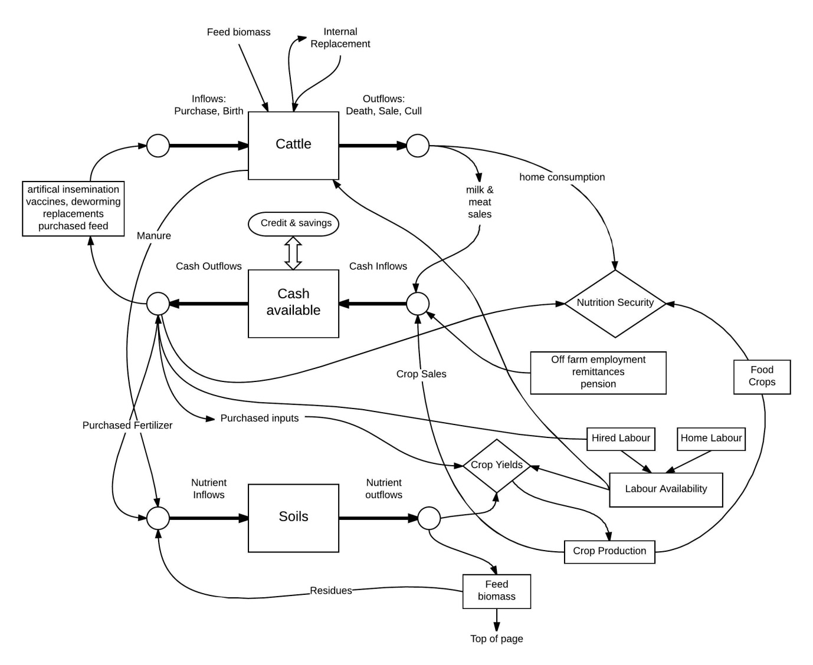

**2.2.2 Dairy cattle**

A livestock simulation sub-model (module) accounts for quantity of cattle by cohort, and the milk offtake per adult female. Cattle are disaggregated by breed (local and improved), sex, and age. The cohorts include male and female calves, heifers, steers, cows, bulls, and castrated adult males. The module runs on a monthly time-step and considers the influence of feed quality and quantity on live weight gain for growing animals and milk yield of adult females for local and improved cattle. This approach is adopted in order to consider the full extent of herd level productivity improvement from feeding and adoption of improved breeds. Feeding higher quality diets in early life can reduce time to sexual maturity, and hence reduce the age of first calving, and increase the total number of calvings and lactations per adult female ((Bagley, 1993; Osuji et al., 2005). Animal numbers for each cohort in each period are determined using stage structured equations which consider the amount of animals moving into and out of a given cohort in each period, and is dependent on the calving interval, mortality rate per cohort, culling due to old age, growth rate, purchases, and sales[2]. The growth rate of young animals (calves, heifers, and steers) is dependent on the dietary energy supply for growth provided in each period (Appendix C). Purchases and sales are endogenously determined. All other parameters are specified based on survey data. A more complete description is provided in Appendix C.

The above factors, as well as reproductive management and preventative health interventions, have been proposed as measures that influence emissions intensity of smallholder dairy systems in East Africa (Mottet et al, 2015). Due to lack of epidemiological data on animal mortality and cost data on breeding, the impact of preventative health measures on animal health/mortality, or of interventions on the efficiency of breeding (i.e. from artificial insemination in place of natural breeding, and reducing the need for breeder males), are not considered.

**2.2.3 Cropping and Grazing**

Dairy households in the Tanzanian southern highlands produce food and fodder crops for food and feed, as well as cash crops for sale (Table 4). The acreage of land dedicated to food, fodder, and cash crops, as well as the yields, labour inputs, and purchased inputs was determined based on the household questionnaire (GLBS, 2018). The simulations treat land allocation between food, fodder, and cash crops as endogenous variables.

[additional aspects of cropping practices; rotations, yields]

The majority of households in the region practice semi-zero grazing, and therefore the supply of biomass for cattle is dependent on the quantity supplied during stall feeding, and the quantity grazed. The quantity of purchased feed, and the household’s land allocation between fodder crops, pasture, food and cash crops, and rangeland determines the availability of biomass. Food and cash crops are a source of crop residues for livestock feed. [specify the proportion of residues used as feed versus soil fertility management]. Pasture is distinguished from rangeland in that pasture land involves cultivation, including sowing, fertilizing, and harvesting, whereas rangeland is exclusively grazed. Many households specified having a degree of seasonal scarcity in forage availability, leading households to herd cattle long distances from the homestead in search of grazing resources. The area of land required for grazing is calculated based on the level of pasture intake needed in addition to the feed provided during stall feeding in order to meet the energy requirements of the herd (Appendix D.4).

Table 3: Baseline production parameters for local and improved cattle

|  |  |  |
| --- | --- | --- |
| Parameter | Local | Improved |
| Daily live weight gain 1,c(kg hd-1 d-1) | 0.25-0.9 | 0.25-0.9 |
| Calving rate 1,c (calves born per adult female per year) | 0.2-0.9 | 0.2-0.9 |
| Maximumlifetimed (years) | 13 | 13 |
| Calf mortalityc (%) | 0.25 | 0.25 |
| Heifer mortalityc (%) | 0.13 | 0.13 |
| Cow mortalityc (%) | 0.07 | 0.07 |
| Age to maturity1,c (first calving)(months) | 18-24 | 18-24 |
| Milk yield per adult female1,c (kg hd-1 d-1) | 4-12 | 7-16 |
| Mature weight1,a (kg hd-1) |  |  |
| Feed intake1,2 (kg DM TLU-1 d-1 ) |  |  |
| Selling price – steers and bullsb (Tsh TLU-1) |  |  |
| Purchase price – adult femaleb(Tsh hd-1) |  |  |
| Purchase price – heiferb(Tsh hd-1) |  |  |

Notes:

1Values shown are ranges to account for the variation between management and household types.

2 Feed intake per animal is a combination of supplemental feeds provided during stall feeding and *ad libitum* feed intake during grazing

Sources:

a Mruttu et al (2016)

b GLBS (2018)

c Calculated

d Bebe et al (2003b)

Table 4: Baseline production parameters of cropping enterprisea

|  |  |  |  |  |  |  |
| --- | --- | --- | --- | --- | --- | --- |
| Crop | Purpose | Yield  (Mg ha-1)  (SD) | Area  (ha) | Labour Inputsb  (peson-days month-1) | Non-labour input cost (Sh ha-1) c | Selling price  (Sh Mg-1)  (SD) |
| Maize | Food and sale | -- |  |  |  |  |
| Beans | Food and sale |  |  |  |  |  |
| Tea | Sale |  |  |  |  |  |
| Banana | Sale |  |  |  |  |  |
| Other cash crops | Sale |  |  |  |  |  |
| Napier | Fodder |  |  |  |  |  |
| Other fodder crops | Fodder |  |  |  |  |  |

Notes:

a Values are means for entire sample population

b Values listed are average for entire growing season. For month specific labour inputs, see supplementary material.

c Non-labour inputs include seeds, fertilizer, pesticides, herbicides, machinery.

**2.2.5 Farm level greenhouse gas emissions**

Given that the objective of the study is to consider the influence of dairy management practices on indirect emissions from land use change, including from reductions in forest disturbance, a consequential life cycle approach was used. Consequential life cycle analysis differs from attributional life cycle analysis in the definition of the system boundary, where the former considers system expansion, and the latter does not (Thomassen et al., 2008). This approach differs from IPCC in that GHG emissions from land use change driven by the dairy sector is considered as attributable to the dairy sector, as opposed to other sectors, such as forestry. This allows for the potential land sparing and emissions offsets from reductions in land occupation to be considered in the estimate of emissions intensity (and absolute emissions) from dairy production.

The farm gate emissions intensity of milk production is expressed as kilograms of carbon dioxide equivalent emissions per kilogram of fat and protein corrected milk (kg CO2eq kg-1 FPCM). [discuss how FPCM is calculated]. This is estimated by summing all sources and sinks of emissions up to the farm gate and dividing by annual milk production (farm gate to retail emissions, including from transport and processing, are not considered). The direct emissions categories considered are therefore: methanefrom enteric fermentation, methane and nitrous oxide from manure management, manure applied on pasture, soils, and in storage, and nitrous oxide from feed crop production.[insert refs for processing and transportation of supplement feeds].

*Indirect greenhouse gas emissions from land use change*

Increasing purchase of feed crops on farm has implications for land use change upstream from the farm and is therefore considered by estimating the emissions from land conversion to cropland. This, as well as land use change on farm from changes in cropland, and total grazing land requirements, are estimated using the stock change method, which involves subtracting the C content of the initial land use from the new land use (IPCC, 2006). C storage values for grassland, cropland, and forest in Tanzania are obtained from Willcock et al. (2012), and take values of 162.1, 127.9, and 416.9 Mg C ha-1 for crop, grassland, and forest, respectively. To consider the variation in initial land uses which undergo conversion, sensitivity analysis is conducted (Section 3.3). As discussed above, the grazing land requirements are calculated based on cattle forage requirements for each simulation. Reductions in forage requirements from grazing both reduces grazing intensity and grazing land requirements. Each simulation analysis involves calculating the total quantity of rangeland required to meet cattle nutrient requirements. The difference in total land use (ha kg FPCM-1) is calculated to assess the extent to which reductions in land use are achieved from efficiency improvement in feed production and livestock.

**2.2 Interventions**

[specify baseline prices of improved cattle, feeds, and interest rates, and the values under the intervention scenarios]

1. **Results**
   1. Model Validation

Validation of the model involves comparing observed herd sizes and composition, milk offtake, and land allocation in the study region to the endogenously determined values from the base model simulation. This ensures that the model reproduces the production characteristics of dairy producers given the same exogenous factors.

* 1. Intervention scenarios

The intervention scenarios are changes in market prices of improved replacement cattle, market prices of supplemental feeds, and the interest rate of loans taken out for investment in the dairy enterprise. Further, these three intervention scenarios are assessed under changes in the farm gate milk price.

The total farm milk production, land use (total feed crop land and grazing area for dairy), farm gate greenhouse gas emissions intensity of milk, household income, and household nutrition security are presented for each scenario.

* 1. Sensitivity analysis

Key sources of uncertainty in the modelling analysis are with respect to biomass yields and labour demands for biomass production. Due to high data requirements for acquiring labour data, and the high data and modelling requirements for estimating crop and pasture yields endogenously, we conduct sensitivity analysis by varying the values for these parameters.

Further, uncertainty exists in the initial land use undergoing conversion to cropland (in the case the household expands total crop production), as well as the types of land cattle graze on. Therefore these two sources of uncertainty are considered in the sensitivity analysis by considering the full range of initial C storage values for the land which undergoes conversion.

1. **Discussion**

Tanzania’s livestock policy has since 1984 focussed on improving input support for small scale as opposed to large scale farmers (Kurwijila, L.R and K.J. Boki. 2003). Is this the most efficient way of improving the productivity of the sector? Are there tradeoffs between efficiency and equity, and can they be quantified? What are the tradeoffs between strategies to reduce greenhouse gas emissions and increase incomes and nutrition security for rural households?

**5.0 Conclusion**

**References**

AFRC. 1993. The Nutrient Requirments of Dairy Cattle (Agriculture and Food Research

Council, CAB International, Wallingford, UK).

Bagley CP 1993. Nutritional management of replacement beef heifers: a

review. Journal of Animal Science 71, 3155–3163.

Bebe. 2003a.

Bebe BO, Udo HMJ, Rowlands GJ and Thorpe W. 2003b. Smallholder dairy systems in the Kenya highlands: cattle population dynamics under increasing intensification. Livestock Production Science 82, 211–221.

Bosire et al 2015

Brooke, A., D. Kendrick, A. Meeraus, R. Raman. GAMS: A User's Guide. Release 2.50 The Scientific Press, Redwood City, CA (2008)

Bryan, E., Ringler, C., Okoba, B., Koo, J., Herrero, M., Silvestri, S.. 2013. Can agriculture support climate change adaptation, greenhouse gas mitigation and rural livelihoods? Insights from Kenya. Climatic Change 118(2): 151-165.

Blaxter KL, Clapperton J. 1965. Prediction of the amount of methane produced by

ruminants. Br J Nutr 19(4):511–522.

Carter, S., M. Herold , M. C. Rufino , K. Neumann , L. Kooistra , and L. Verchot. 2015. Mitigation of agricultural emissions in the tropics: comparing forest land-sparing options at the national level. Biogeosciences, 12, 4809–4825

Charles Peter Mgeni and Salim Nandonde (SUA). 2012. Targeting dairy value chains in Tanzania: Process towards benchmark survey.

United Nations Food and Agriculture Organization (FAO). 2017. Statistics. http://www.fao.org/faostat/en/#data

United Nations Food and Agriculture Organization (FAO). 2013. Climate-smart agriculture sourcebook. FAO, Rome.

FAO. Global Forest Resources Assessment 2010, Main Report, FAO Forestry Paper

163. Food and Agriculture Organization of the United Nations, Rome, 2010.

Gerber. 2007.

GLBS (Greening Livestock Baseline Survey). 2018. International Livestock Research Institute.

Hammond, J., Simon Fraval, Jacob van Etten, Jose Gabriel Suchini, Leida Mercado, Tim Pagella, Romain Frelat, Mats Lannerstad, Sabine Douxchamps, Nils Teufel, Diego Valbuena, Mark T. van Wijk. 2017. The Rural Household Multi-Indicator Survey (RHoMIS) for rapid characterisation of households to inform climate smart agriculture interventions: Description and applications in East Africa and Central America 151: 225-233

Havlik. 2014.

Herrero, M., Havlik, P., Valin, H., Notenbaert, A., Rufino, M., Thornton, P., Blummel, M., Weiss, F., Grace, D., Obsersteiner, M.. 2013. Biomass use, production, feed efficiencies and greenhouse gas emissions from global livestock systems. PNAS 110 (52): 20888-20893

Hosonuma et al. 2012.

Kurwijila, L.R and K.J. Boki. 2003. A review of the small scale dairy sector – Tanzania. Milk

and dairy products, post-harvest losses and food safety in Sub-Saharan Africa and the near

East. FAO Prevention of Food Losses Programme. FAO, Rome, Italy.

Livestock Sector Development Programme (LSDP). 2011. Ministry of livestock and fisheries development. United Republic of Tanzania.

Tanzania Livestock Sector Analysis (LSA) Baseline 2016 and Projections to 2031: Livestock Production & Household Economy Tanzanian Livestock Master Plan, Technical Advisory Committee (TAC) Meeting, Colosseum Hotel, Dar Es Salaam 23 June 2016 Stephen Michael, Francis Makusaro (Ministry of Agriculture, Livestock and Fisheries Development) & Solomon Desta (ILRI)

NBS. 2016. Njombe District Council Socio-Economic Profile. 2016.

Ministry of Agriculture, Livestock, and Fisheries (MALF). 2016. Baseline study of the dairy value chain in Tanzania. Assessment of Challenges and Opportunities for Investment. United Republic of Tanzania and Royal Danish Embassy.

Ministry of Livestock Development. 2006. National livestock policy. Dar es Salaam: United Republic of Tanzania.

Omamo, S.W., Diao, X., Wood, S., Chamberlin, J., You, L., Benin, S., Wood-Sichra, U. and

Tatwangire, A. 2006. Strategic priorities for agricultural development in Eastern and Central

Africa. Washington DC: International Food Policy Research Institute

Osuji PO, Saarisalo EM, Tegegne A and Umunna NN 2005. Undernutrition of dairy cattle in smallholder production systems in East Africa. In Coping with feed scarcity in smallholder livestock systems in developing countries (ed. AA Ayantunde, S Fernandez-Rivera and G McCrabb), pp. 97–120. Animal Sciences Group, Wageningen UR, Wageningen, The Netherlands; University of Reading, Reading, UK; ETH (Swiss Federal Institute of Technology), Zurich, Switzerland; and ILRI (International Livestock Research Institute), Nairobi, Kenya.

Paul, B.K., R. Frelat, C. Birnholz, C. Ebong, A. Gahigi, J.C.J. Groot, M. Herrero, D.M. Kagabo, A. Notenbaert, B. Vanlauwe, M.T. van Wijk. 2017. Agricultural intensification scenarios, household food availability and greenhouse gasemissions in Rwanda: Ex-ante impacts and trade-offs. Agricultural Systems

Pfeiffer et al (2012).

Shikuku, K.M., Validivia, R.O., Paul. B.,K., Mwongera, C., Winowiecki, L., Laderach, P., Herrero, M., Silvestri, S.. 2017. Prioritizing climate-smart livestock technologies in rural Tanzania: A minimum data approach. Agricultural Systems 151: 204-216.

Thornton, P., Herrero, M., Freeman, A., Mwai, O., Rege, E., Jones, P., McDermott, J., 2007.Vulnerability, Climate change and Livestock – Research Opportunities and Challenges for Poverty.

Tubiello, F.N., Soussana, J.F., Howden, S.M., 2007. Crop and pasture response to climate change. Proc. Natl. Acad. Sci. 104, 19686-19690.

Valdivia et al (2012)

Valin, H., Havlik, P., ,Mosnier, A., Herrero, M., Schmid, E., and M, Obersteiner. 2013. Agricultural productivity and greenhouse gas emissions: trade-offs or synergies between mitigation and food security? Environmental Research Letters 8: 035019

Weiler, V., Henk MJ Udo, Viets, T., Crane, T.A., De Boer, I.JM.. 2014. Handling multi-functionality of livestock in a life cycle assessment: the case of smallholder dairying in Kenya. Current Opinion in Environmental Sustainability 8:29–38

**Appendix A – Summary Statistics of Household Survey Data**

[monthly labour data and other summary statistics goes here]

**Appendix B – Summary of household mathematical programming model**

**B.1 Objective function**

The household mathematical programming model is summarized as follows. The model maximizes an objective function subject to a series of constraints and identities which define household resource endowments, and the relationships between the endogenous decision variables and production. The mathematical specification of the model is as follows:

Maximize U = NPV - $∅×σ$

By choosing area allocated to food, cash, and fodder crops, and replacement and feed purchases for the dairy enterprise, and,

Subject to:

Household cash constraint,

Household labour constraint,

Household arable land for crop production,

Household total crop and pasture land,

and model identities defining relationships between the decision variables and farm production.

The above objective function is further defined as follows: U is the household’s utility function, NPV is the net present value of the household, including farm income, farm assets, and food consumption, $σ$ is the standard deviation of net present value, and $∅$ is the risk aversion coefficient. Off farm income is assumed exogenous.

Net present value is further defined as follows:

NPV = $\frac{\sum_{y}^{Y}{Farm Income + Livestock Assets + Value Food Consumption}}{{(1+r)}^{ y}}$

Where FI is farm income (TSh yr-1), the sum of CI, crop income (TSh yr-1) , LI, livestock income (TSh yr-1) , and Livestock Assets (TSh). VFC is the value of food consumption (TSh yr-1). A 10 year horizon is set (Y = 10). The discount rate used is 4 %.

Crop income is revenues from crop sales minus cash expenses on crop inputs. The selling prices of crops and prices of inputs are specified in Table 4 and section 2.1.1 of the text, respectively. Cash expenses on crop inputs include fertilizer, seeds, and labour. Cash expenses on the dairy enterprise include replacements, feeds, breeding services, health services, and hired labour.

The types of risk considered are biomass yields (crops and pasture), and output prices (crops and milk). Variation in the biomass yields are specified based on the historical standard deviation of the individual types of biomass, in relation to a trend line (representing annualized average change in yields) (see text Table 4). The standard deviation of net present value, $σ,$ is then calculated based on the standard deviation of the underlying yields and prices.

**B.2 Cash constraint**

The cash constraint considers the inflows and outflows of cash for the household in each time period. It is defined as follows:

Farm Incomey + Off Farm Incomey = Farm Expensesy + Household Expenditurey + Net Savingsy

Where Off Farm Income (TSh yr-1) is equal to off farm employment income, pensions, and remittances. Farm expenses are the sum of expenses for crop and livestock production (as described above). Household expenditure is the sum of cash expenses for household food and non food expenses. Food expenses by the household are defined below. Non food expenses are set at __ % of annual household income. Net savings is equal to savings in year y (TSh yr-1) minus loans in year y (TSh yr-1). Annual expenses on credit/loans are equal to the size of the loan multiplied by the interest rate (TSh yr-1).

**B.3 Labour Constraint**

A household level labour balance equation ensures that total labour requirements for farm activities is supplied by either home or hired labour. The farm activities include labour allocation per crop and livestock.

Labour_Requirement,m = +

Where

Labour_Requirement m is the total household labour requirement for farm activities in month m

${Crop_Area}_{c,m}$ is the area dedicated to crop c (ha)

${qLab_C}_{c,m}$ is the required labour input for crop c in month m (person days per month)

${Q_Anl}_{a}$ is the quantity of cattle (hd) in cohort a

a is the quantity of labour input per head of cattle in cohort a (person-days per month)

The index a includes all cohorts of cattle in the herd, including male and female calves, heifers, steers, cows, castrated adult males, and bulls

The following equation specifies the source of labour for farm activities:

Labour_Requirementm = Home_Labourm + Hired_Labourm

Where

Home_Labourm is the total availability of labour from household members (person-days per month)

Hired_Labourm is the quantity of hired labour (person-days per month)

**B.4 Arable land constraint**

$\sum_{c}{{Crop_Area}_{c}}$ $≤$ Arable land area

Where

Arable land area is the total land holdings of the household (owned plus rented) which are arable) and suitable for growing crops (ha).

**B.5 Land constraint**

+ Pasture_Land $≤$ Total land holdings

Where

Pasture_Land is total land dedicated to pasture production (ha)

Total land holdings is total land holdings of the household (owned and rented) (ha)

**B.6 Household expenditure**

A Linear Expenditure System, as used in Louhichi and Gomez y Paloma (2014), calculates the quantity of food consumed by the household each year:

piqi = γi +βi (I − ∑ γj pj )

Where

0 < βi < 1

$\sum_{i}{B_{i} }$ = 1

qi – γi >0

where pi is the price of good i, qi is the quantity of good i consumed by the household; I is household income from farm and non-farm activities. βi and Υi are the parameters in the Linear Expenditure System. This system considers ∑γjpj as subsistence expenditure and I− ∑γjpj as supernumerary income (Sadoulet and de Janvry, 1995). To compute βi and Υi we adapted the income elasticities of food demand for Tanzania from Chongela et al (2014) and the Frisch parameter for Africa south of the Sahara from Aguiar et al. (2016).

**Appendix C – Livestock**

**C.1 Stage structured mathematical accounting of herd cohorts**

The quantity of cattle of a given breed and cohort in each time period are defined in the following equation:

Qm,a,b = Qm-1,a,b - Net transitsm-1,a,b− Deathsm-1,a,b- Offtakem-1,a,b + Birthsm-1,a,b + Purchasesm-1,a,b

Where Qm,a,b is the quantity of cattle of a given breed, b, a given cohort, a, in month m, Transits represents the fraction of animals that transition from one cohort to the next, Deaths represents the fraction of animals that exit due to mortality, Offtake represents the animals that are culled for meat consumption (at home or sold), Net Purchases is equal to purchase of replacement animals minus those sold, and Births represent new born calves that are born from adult females maintained by the household. The cohorts include male and female calves, heifers, steers, adult females, and bulls. The breeds include local (Bos Indicus) and improved (Bos Taurus, potentially mixed with Bos Indicus).

The specification of the above parameters for stage structured demographics are based jointly on model parameters, and endogenous variables dependent on household decision making. The transits are calculated based on the growth rate and the amount of time from which calves transfer to heifers/steers, and heifers/steers transfer to adults. The offtake regime is also dependent on household management. For households relying on sexed semen, males are kept within the herd in a ratio sufficient to reproduce. The ratio of adult males to females for self reproducing households is based on sex ratios obtained from GLBS (2018). For households relying on AI, males are sold after reaching maturity. Adult females are maintained until the end of life and sold for meat. Deaths are equal to the cohort specific mortality rate multiplied by animals per cohort. Births per adult female are dependent on the calving interval.

Replacement heifers and cows are purchased in order to sustain the herd (internal replacement rate is not sufficient to meet household requirements for cows). Purchases on replacement females are needed as smallholder dairy herds are generally not self sustaining (Bebe et al, 2003a). Therefore, the purchases of replacement heifers and cows is sufficient to maintain the desired cow population on farm.

**C.2 Productivity at individual animal level**

Table C.2: Feed dependent animal productivity

[the productivity parameters for different diet regimes gets described here]

|  |  |  |  |  |
| --- | --- | --- | --- | --- |
|  | Bos Indicus | | Bos Taurus | |
|  | Calves | | | |
|  | Growth rate (kg/hd/d) |  |  |  |
| Extensive |  |  |  |  |
| Medium |  |  |  |  |
| Intensive |  |  |  |  |
|  | Heifers | | | |
|  |  |  |  |  |
| Extensive |  |  |  |  |
| Medium |  |  |  |  |
| Intensive |  |  |  |  |
|  | Cows | | | |
|  | Milk Yield (kg/hd/d) |  |  |  |
| Extensive |  |  |  |  |
| Medium |  |  |  |  |
| Intensive |  |  |  |  |

**Appendix D – Cropping and grazing**

**D.1 Arable land constraint**

$\sum_{c}{{crop_area}_{c,y}}$ ≤ Arable land area

Where

crop_areac,y is area dedicated to crop c in year y (ha)

land_holdings are total land holdings of the household (sum of owned and rented land) (ha)

**D.2 [rotation constraints]**

**D.3**

**D.4 Grazing land requirements**

Land required for cattle grazing per household is estimated based on the quantity of cattle owned by the household, the quantity of pasture consumed *ad libitum*, and the average pasture yield of grazing land:

Grazing Land y =

Where

Grazing Land is the quantity of grazing land in year y required to provide forage intake for the herd (ha)

DM Intake is the *ad libitum* dry matter intake of grazed pasture for animals in cohort a (Mg TLU-1 yr-1)[3]

Pasture yield is the average dry matter yield of pasture land (Mg yr-1)

**Appendix E – Estimation of farm level greenhouse gas balance**

**E.1 Enteric fermentation**

**E.2 Manure methane and nitrous oxide**

**E.3 Nitrous oxide from managed soils**

**E.4 Land use change**

**E.4.1 Conversion of grassland**

**E.4.2 Conversion of forest**

1. Positive, as opposed to normative analysis, is a concept in the social sciences used to distinguish between the description and explanation of economic phenomena, including behaviour, as opposed to the expression of value or normative judgements.
2. This approach has previously been described in Hary (2004).
3. Note this value is calculated as the required feed intake in addition to the feed provided during stall feeding.